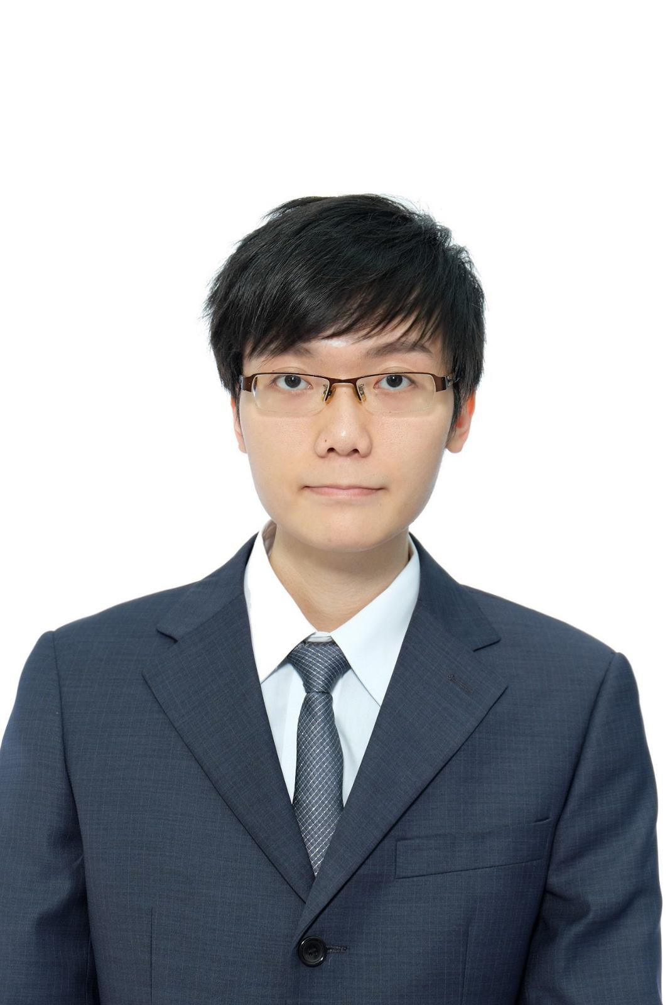

**Pakco Kan**

**DIPLOMAS Y HOBBIES**

**Formaciones :** Diplomados, Congresos, xxxxxxxxxx xxxxxx xxxxxxxxx xxxxxxxxxxxxxxxxx

**Hobbies:** xxxxxxxxxxxxxxxxxxxxxxxxxxxxxx



System Analyst

**ABOUT ME**

5+ years in banking and finance industry. Experienced in various projects like core bank system migration (T24), Murex implementation and Full License bank project.

**DOB:** 19 May 1992 **Phone:** 6204 7765

**E-mail:** pakco2@gmail.com

**EDUCATION**

2013 - 2015 BEng in Computer Science

*The Hong Kong University of Science & Technology*

2011 – 2013 Associate of Science in Network and System Administration

*Community College of City University*

2004 - 2011 HKALE, HKCEE

*Ho Lap College*

**LANGUAGES**

Cantonese: Native

English: Fluent

Mandarin**:** Fluent

**WORK EXPERIENCE**

**Bank of Shanghai (Hong Kong)**

Assistant Vice President, System Analyst

- Mainly responsible for T24 core bank system including project coordination with vendor, Insight reports development by SSRS, COB, and Insight ETL.

- Also provide support to other products in Treasury, Risk Management.

- Ongoing project: Murex implementation, Full license bank project.

**Orix Asia Limited (A Restricted License Bank)**

Analyst Programmer

- Responsible for EXCEL Loan System (ELS) development and The Loan Origination System (LOS) support and testing.

- Participate in Full systems development life cycle (SDLC) of the ELS application and reports. Key achievement is to automate the programs and reports at day end.

- Completed project: Redesign and develop insurance and license reminder, monthly statement.

12/2019

now

08/2018

12/2019

**1**



**SKILLS**



* SQL
* Microsoft SSRS
* Temenos T24
* Oracle Database
* Oracle Report Builder
* Oracle Form
* Java
* .Net
* VBA
* Unix shell script
* PL/SQL

**Pakco Kan**

**DIPLOMAS Y HOBBIES**

**Formaciones :** Diplomados, Congresos, xxxxxxxxxx xxxxxx xxxxxxxxx xxxxxxxxxxxxxxxxx

**Hobbies:** xxxxxxxxxxxxxxxxxxxxxxxxxxxxxx



System Analyst

**WORK EXPERIENCE**

**Chong Hing Bank**

Senior Programmer

- This post begins with the maintenance of Customer Information (CIF) of old core back system, and then mainly focusing on the new core back migration to Temenos T24

- Completed project: Study from vendor the operation and development of T24. Completed first part of the T24 migration (CIF)

**Agriculture, Fisheries and Conservation Department**

Summer Internship Programme

- Design Ocean Park and exhibition animal inventory database

- Completed project: A statistic tool for AFCD to find inadaptable species imported by Ocean Park.

06/2015

08/2018

08/2018

12/2019

**2**



